Import Data using Transform Maps (Spreadsheet)
Milestone 2 : Creation Of importset Table And Transform Map
Activity 3 : Create Importset Table
Import Set Table
The Import Set Table is a temporary staging table used to store employee data uploaded from the spreadsheet. It contains fields such as Employee ID, Name, Email, Department, and Location. The imported data is stored in this table before it is validated and transformed into the final employee records.

Navigation:
1.Go to Application Navigator
2.Load Data

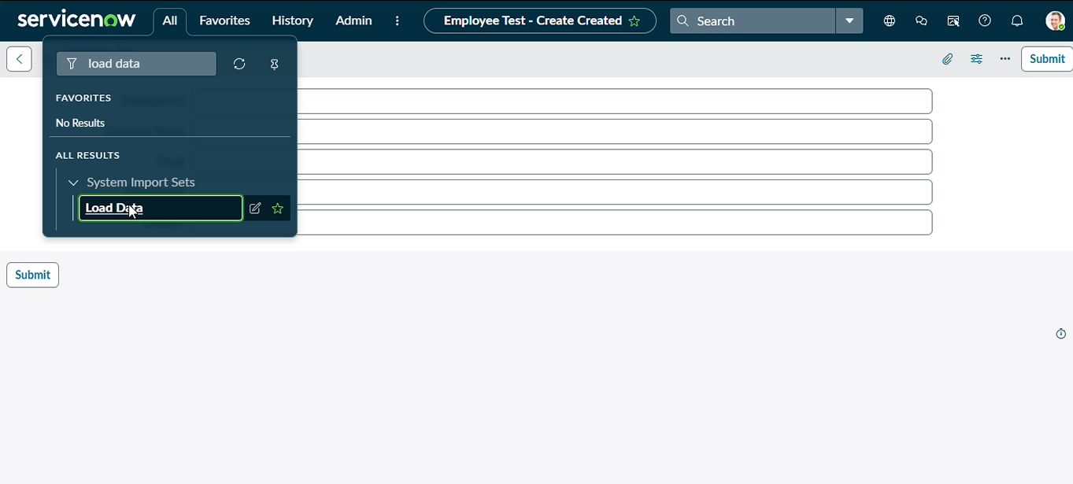
3.Click on Load Data and create an import table
4.Fill details as shown below
5.Label: Employee Import
6.Name: u_employee_import (auto populated)

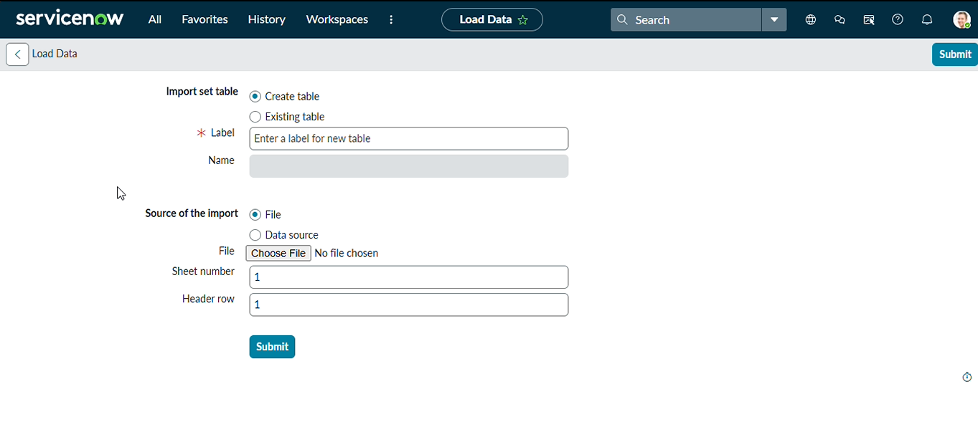
7.Click on Submit
8.Once we click on Submit, we can see the success message as shown below.
9.Also we need to make sure to click on Create Transform Map.

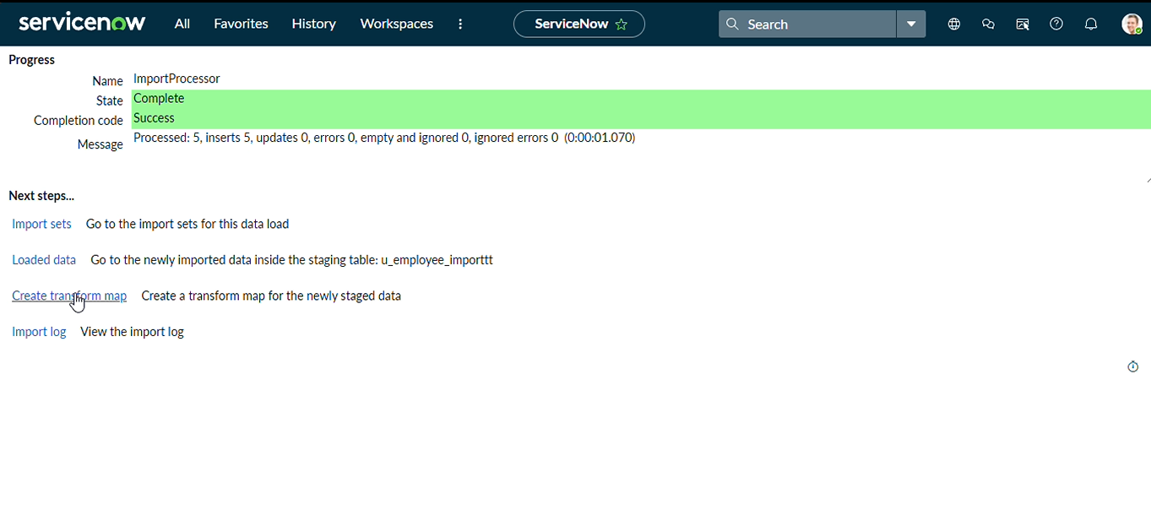

Activity 4 : Create Transform Map
Transform Map
The Transform Map defines how data from the Import Set Table should be transferred to the target Employee table. It maps fields such as Employee ID, Name, Email, Department, and Location from the imported data to the corresponding target fields. Employee ID can be used as the coalesce field to update an existing employee record or create a new record when the employee does not already exist.
1.Give inputs as shown below.
2.Name: Sample Spreadsheet Import
3.Source Table: Employee Import is auto-populated
4.Target Table: Employee Test - as we created earlier
5.Click on Auto Map Matching fields.

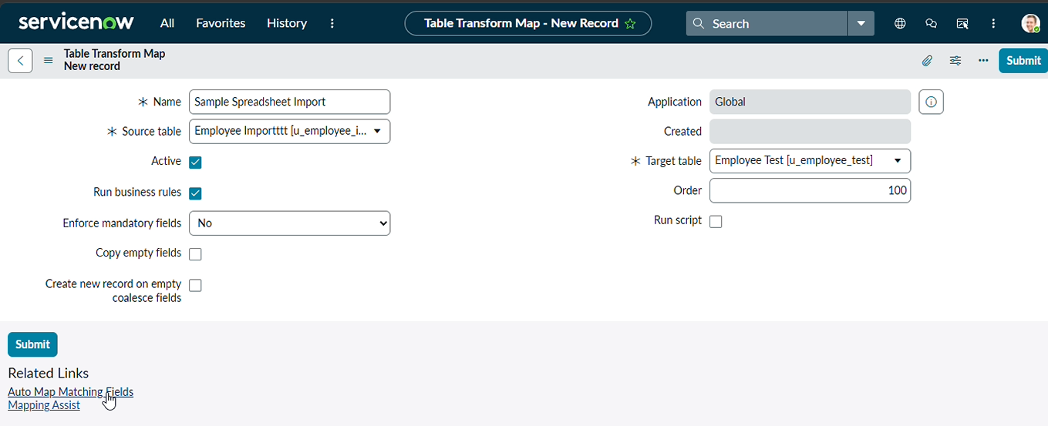

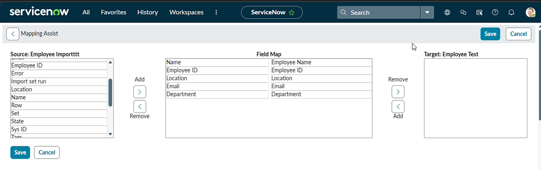
6.Click on Save
7.Make sure the both Source & Target table fields are mapped as shown below.

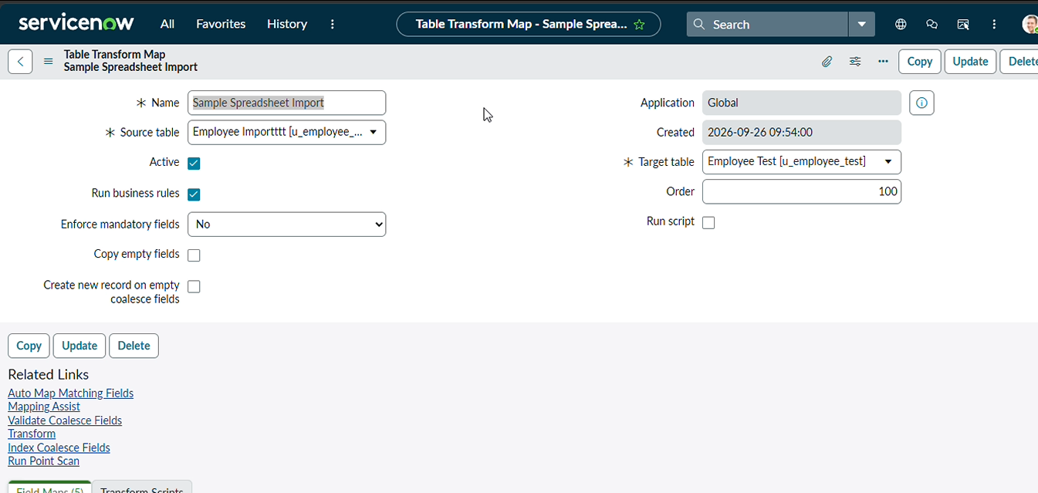
9.Now click on Transform link as shown below

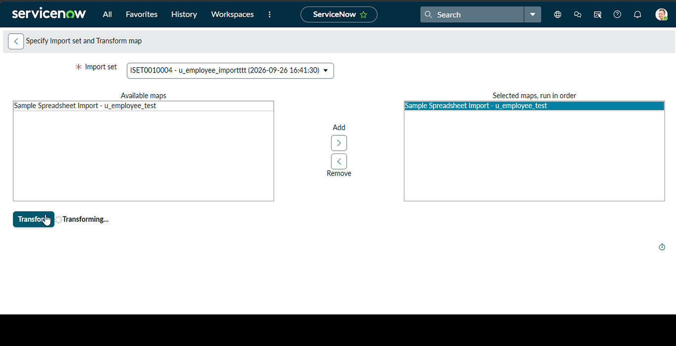
10.After clicking Transform, make sure you see the success message as shown below.
